**WSSO Signon**

* This is the login screen to enter the PTA application.
* To enter your User name either scan your employee badge or type in your BEMS.
* Type in your Windows/Network password. It is case sensitive.
* Click the Login button.
* If logon is unsuccessful, an error message will be displayed, and you can try again.
* Upon successful login, you will be presented with the Main Menu.

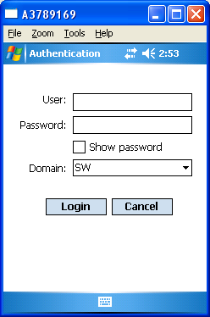

**Main Menu – Example 1**

* The Main Menu shows a list of all your available transactions.
* If the list is empty or the transaction that you wish to run is not in the list, then contact your PTA focal.
* If any message appears on the Main Menu and your transaction is not in the list, then contact your PTA focal.

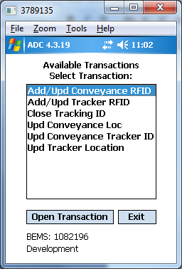

**Main Menu – Example 2**

This is a second view of the Main Menu showing a list of available transactions for a second employee.

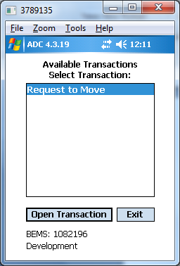

**Add/Update Tracker RFID**

* This screen adds or updates a tracker RFID.
* Scan a tracker barcode.
* Scan an RFID number barcode or key it in.
* Click Submit to execute this transaction.
* If the transaction was successful, the message: “Transaction successful” will be displayed
* If the transaction failed, the message: “Transaction failed” will be displayed and a pop up message box will show the details.
* Click Clear to clear all entries.
* Click Exit to close this screen and return to the Main Menu.

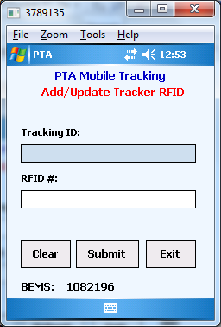

**Close Tracking ID**

* This screen closes a tracker.
* Scan a tracker barcode.
* The transaction will be automatically executed. There is no Submit button.
* If the transaction was successful, the message: “Transaction successful” will be displayed
* If the transaction failed, the message: “Transaction failed” will be displayed and a pop up message box will show the details.
* Click Exit to close this screen and return to the Main Menu.

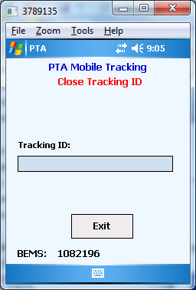

**Update Conveyance Location**

* This screen updates a conveyance location.
* Scan a shop location barcode.
* Scan a conveyance barcode.
* The two barcodes can be scanned in any order.
* The transaction will be automatically executed when two barcodes have been scanned. There is no Submit button.
* If the transaction was successful, the message: “Transaction successful” will be displayed
* If the transaction failed, the message: “Transaction failed” will be displayed and a pop up message box will show the details.
* Click Clear All to clear all entries.
* Click Exit to close this screen and return to the Main Menu.

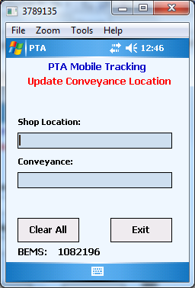

**Update Conveyance Tracker ID**

* This screen updates a conveyance tracker ID.
* Scan a conveyance barcode.
* Scan a tracker barcode.
* The two barcodes can be scanned in any order.
* The transaction will be automatically executed when two barcodes have been scanned. There is no Submit button.
* If the transaction was successful, the message: “Transaction successful” will be displayed
* If the transaction failed, the message: “Transaction failed” will be displayed and a pop up message box will show the details.
* Click Clear All to clear all entries.
* Click Exit to close this screen and return to the Main Menu.

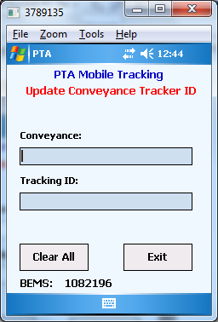

**Update Tracker Location**

* This screen updates a Cart/Rack Location.
* Scan a shop location barcode.
* Scan a tracker barcode.
* Optionally, scan a cart/rack location – this is not a required field
* The three barcodes can be scanned in any order.
* Click Submit to execute this transaction.
* If the transaction was successful, the message: “Transaction successful” will be displayed
* If the transaction failed, the message: “Transaction failed” will be displayed and a pop up message box will show the details.
* Click Clear to clear all entries.
* Click Exit to close this screen and return to the Main Menu.

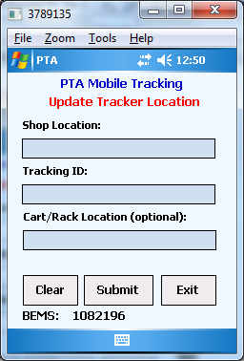

**Request To Move Tracker**

* This screen moves a tracker from one location to a second location
* Scan a tracker barcode.
* Scan a from location barcode or key it in.
* Scan a to location barcode or key it in.
* The three barcodes can be scanned in any order.
* Click Submit to execute this transaction.
* If the transaction was successful, the message: “Transaction successful” will be displayed
* If the transaction failed, the message: “Transaction failed” will be displayed and a pop up message box will show the details.
* Click Clear to clear all entries.
* Click Exit to close this screen and return to the Main Menu.

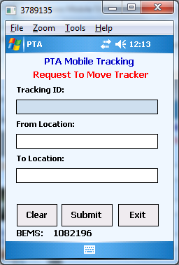

**Add/Update Conveyance RFID**

* This screen adds or updates a Conveyance RFID.
* Scan a conveyance barcode.
* Scan an RFID number barcode or key it in.
* Click Submit to execute this transaction.
* If the transaction was successful, the message: “Transaction successful” will be displayed
* If the transaction failed, the message: “Transaction failed” will be displayed and a pop up message box will show the details.
* Click Clear to clear all entries.
* Click Exit to close this screen and return to the Main Menu.

